**Name:** Umar Tariq

**Drug Classification:**

There are thousands of different drugs, both legal and illegal. Because of this variety, it is often necessary to classify drugs into several types for legal, medical and treatment purposes. There are several ways to classify drugs, including by chemical similarities, effects on the mind and body, and legal definitions.

**About Dataset:**

This data has been collected from a drug company which has labelled data set of the drugs and the parameters that effect it. Therefore, on the basis of the disease and the type of patient the drug is recommended. The link to the original dataset can be found below.

And my dataset about classification problem.

The feature sets : Age Sex Blood Pressure Levels (BP) Cholesterol Levels Na to Potassium Ration.

1. Using SVM Algorithm:

First import the libraries then preprocessed data

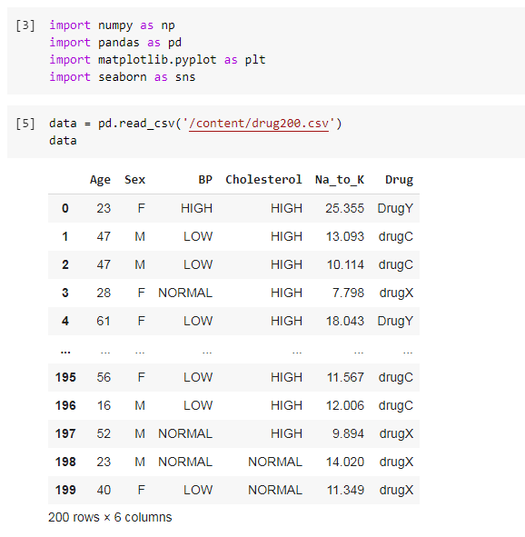

**Data Exploration**

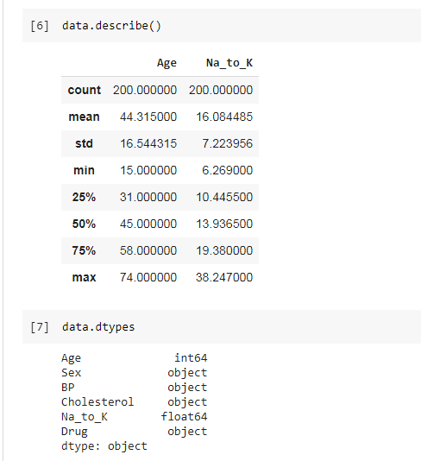

This part aims to determine the missing value in this data and visualization

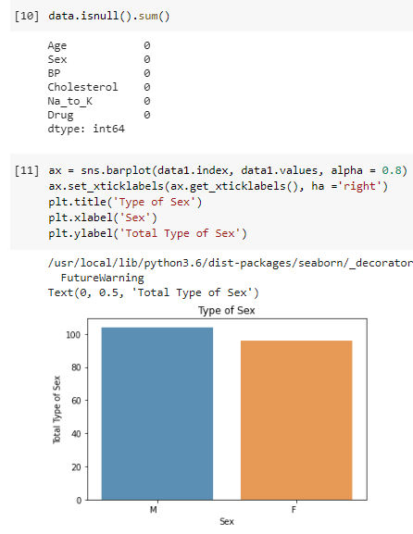

Splitting data into training and testing

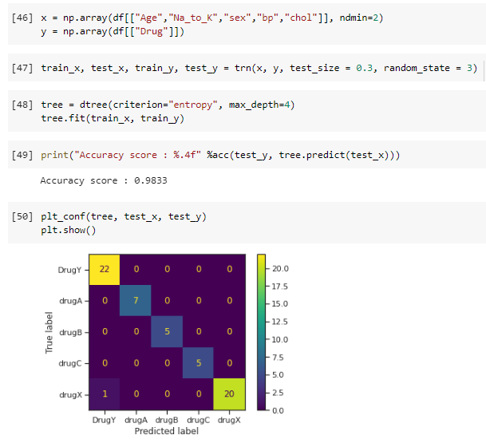

Accuracy of svm classification on this training is 0.88

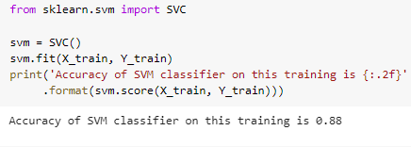

1. K-nearest-neighbors Algorithm

First import the libraries then Show the dataset

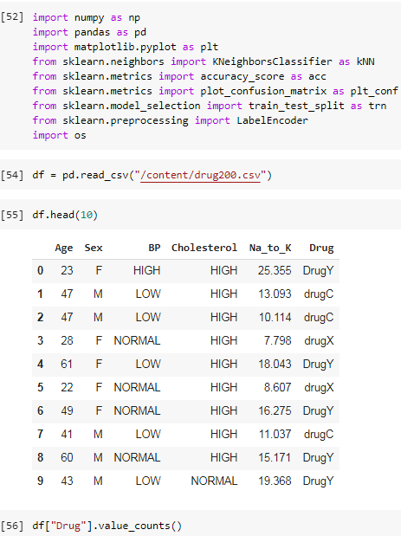

Splitting data into training and testing dataset

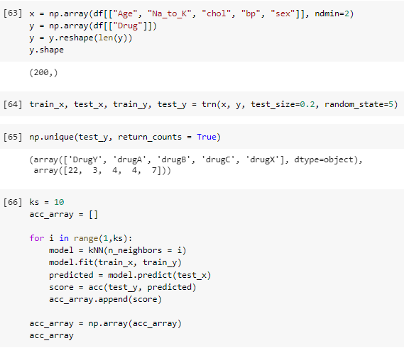

The highest accuracy of 0.8 was with 7 neighbors and predicted labeled.

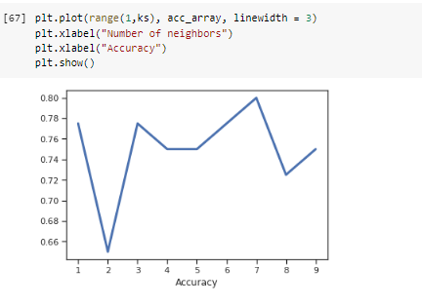

Test x and test y Predicted Label

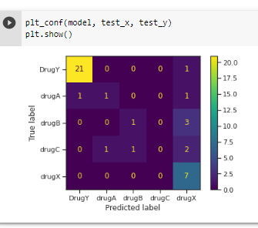

1. Decision Tree Algorithm

First import the libraries then Show the dataset

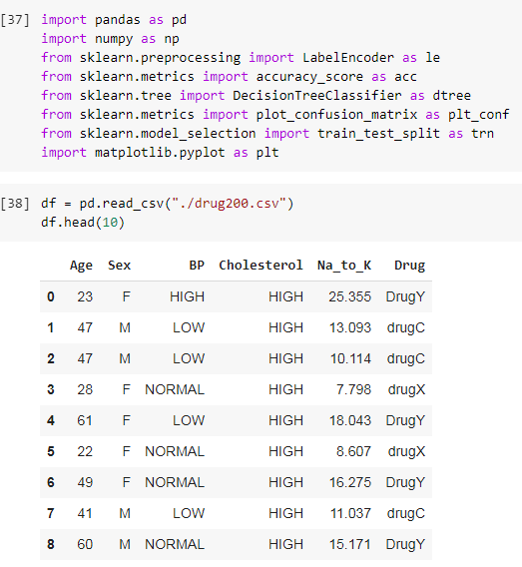

Label Encoding

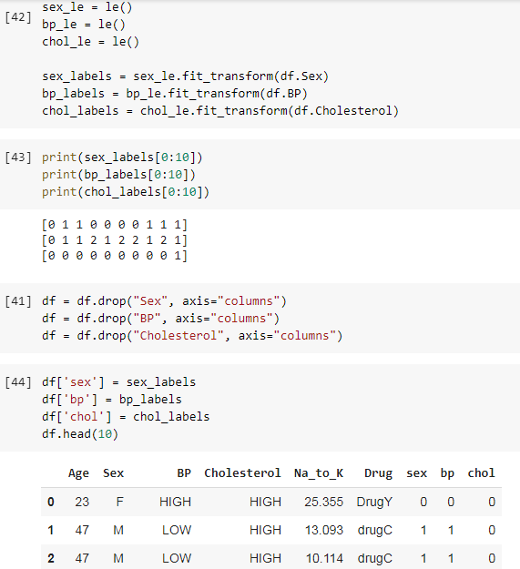

Train Test Split the data

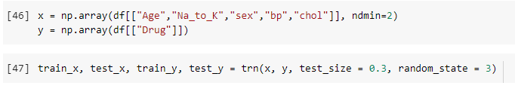

Making of model

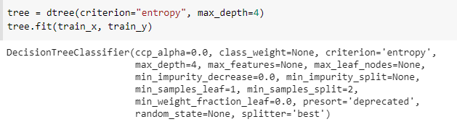

Accuracy of decision tree classification on this training is 0.9833

Test x and test y Predicted Label

